**Program 4:** Design Wireframes for project Online Laptop Shopping Web Application based on Web Design Principles.

I have used Figma Platform to wireframe my ideal website, which is branded InnoGagdets. In the entire mockups, I have chosen a color palette of almost three colors: orange for buttons, red for some cards on dashboard and shades of green for other pages. Basically, it has five pages: Homepage is the main landing page that clients are likely to see whenever they visit my website, Registration page (Sign up page) for a clients and admin to be able to buy and manage products accordingly. Login pages for both Seller and Customer and one more for an Admin of the system who fares up daily Transactions and perform different other tasks in store through the main dashboard.

Normally, all business’s target is to attain potential customers and sells out as much as they can so that the incomes is an achievement every time and that is what motivates them to look for experts in user interface and user experience dabbed UI/UX so that they can present themselves well on internet. Those customers are all over and in this era, they are mostly using internet than any other convectional way. That is why businesses in this time around are trying the best and all means to reach out customers with different approaches. One of used those approaches is clean and professional website. Well-designed website plays essential role to advertise and sells out the business products. In fact, website is one the business mutual property and brand whenever e-commerce is concerned. It is should be designed with much consciousness and attentiveness to make sure that it never undermines the business quality and capacity. This also applies to non-profit organizations and broadly to person portfolios as well. If it is meant to communicate to the public, it should do it effectively. Ideally, website should represent you and give great impression.

1. **Category Page**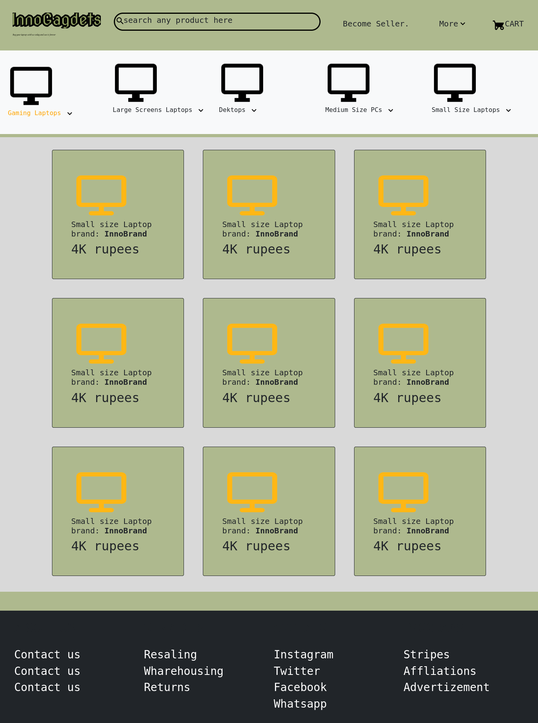
2. **Product Page**

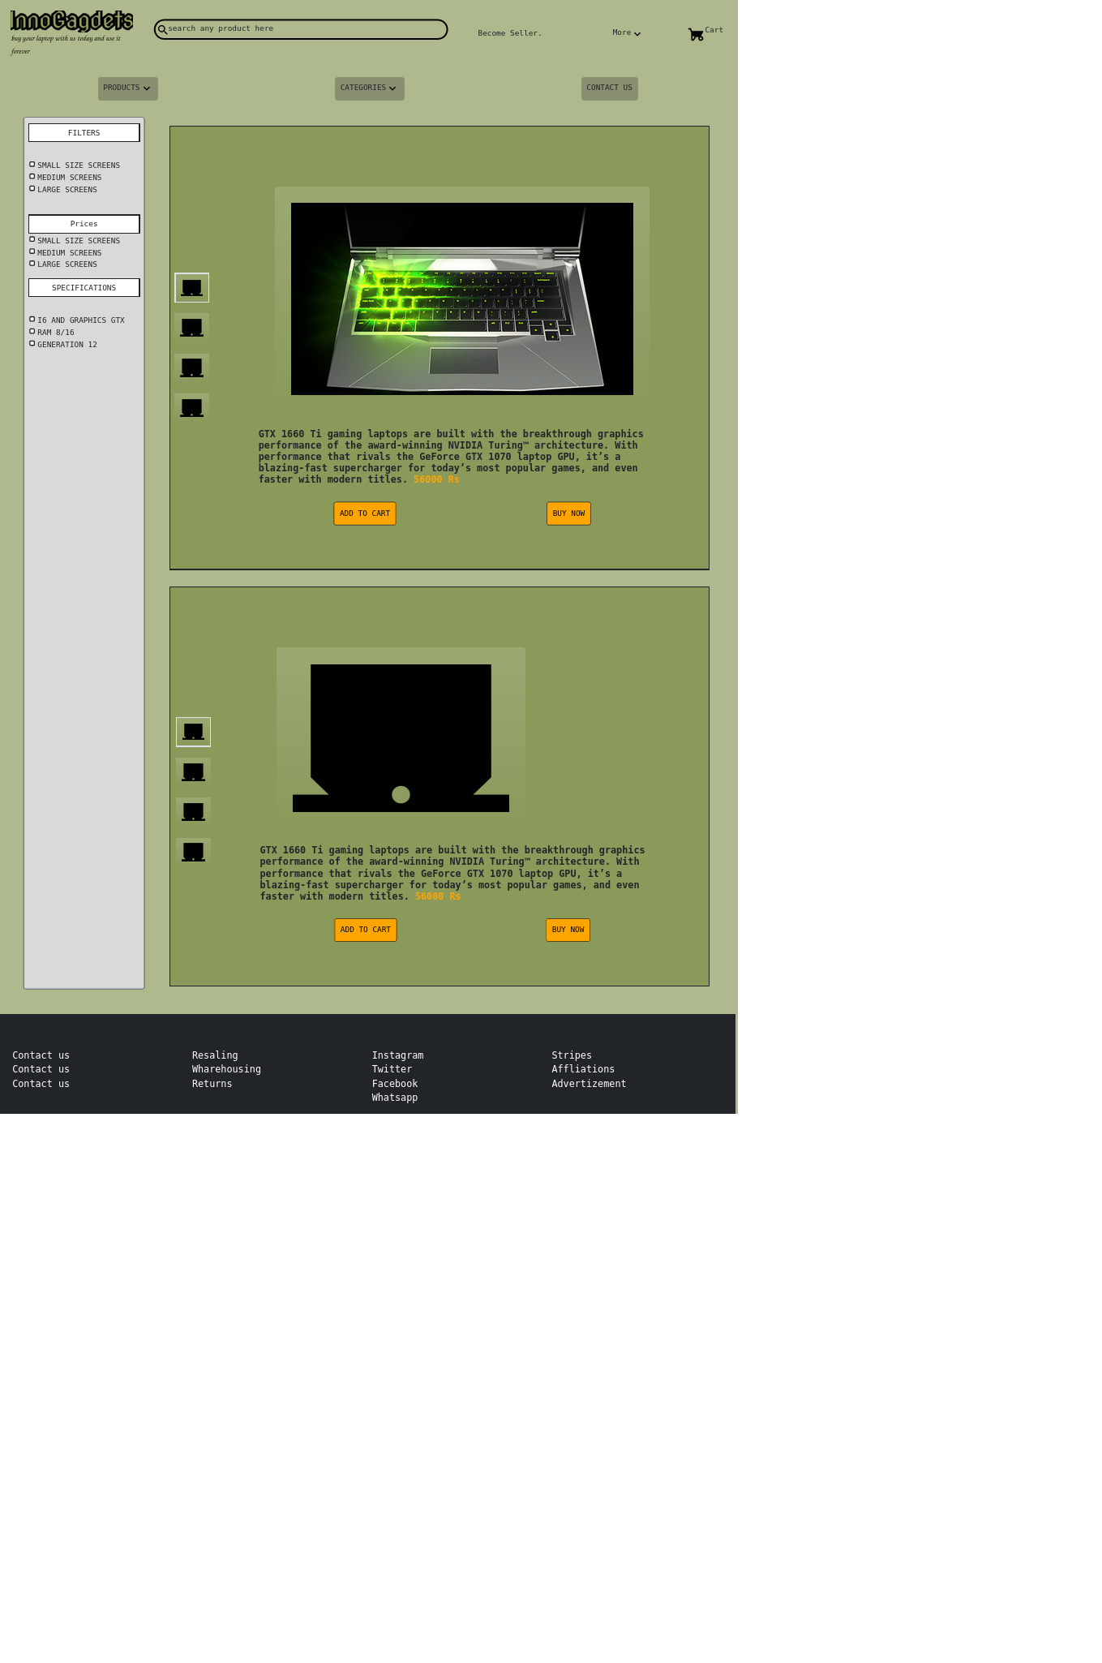

1. **Admin Login**

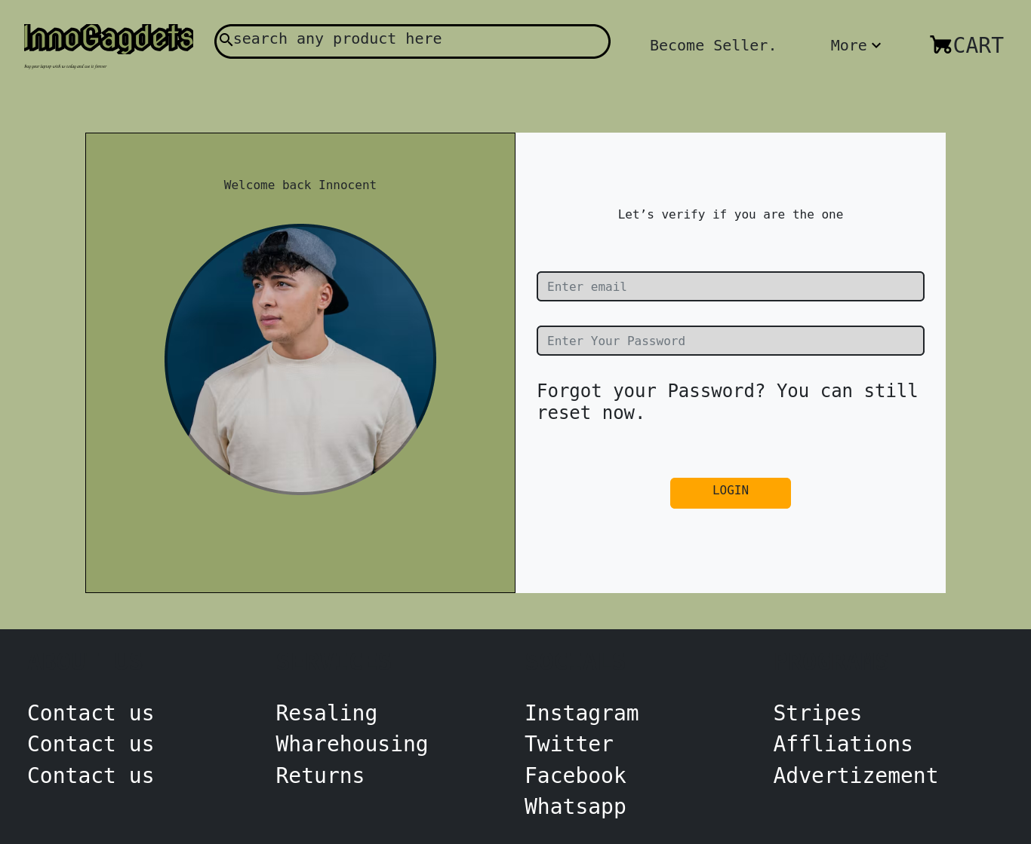

1. **Product Management (Admin Side)**